Marketing Research.

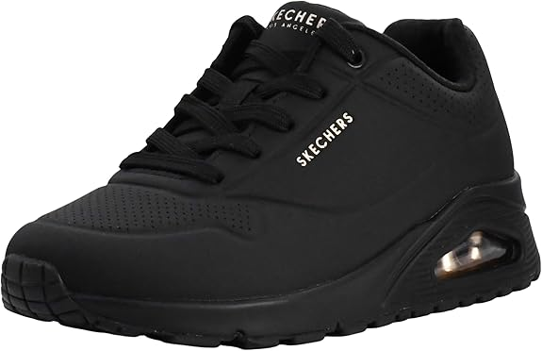
01.Skechers Women's Uno - Stand On Air Sneaker.
LKR19,034.73
LKR 37,781.06 Shipping & Import Charges to Sri Lanka.

Product details
Top highlights
Fabric type
100% Synthetic
Origin
Made in the USA or Imported
Fur description
Skin-free
Sole material
Rubber

About this item
- PREMIUM COMFORT TECHNOLOGY: Experience superior cushioning with Air-Cooled Memory Foam insole and visible air-cushioned midsole - perfect memory foam shoes for women
- STYLISH WEDGE DESIGN: Fashion-forward silhouette features a hidden 1.5-inch heel and smooth perforated durabuck upper for elevated style in these memory foam womens shoes
- SUPERIOR TRACTION: Flexible rubber outsole provides reliable grip and stability while the memory foam shoes technology ensures lasting comfort
- VERSATILE FASHION: Classic lace-up closure system allows for a secure, adjustable fit perfect for casual or athletic wear
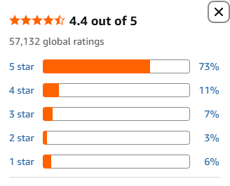

https://www.amazon.com/Skechers-Street-Stand-Womens-Sneakers/dp/B07H61JFTT/ref=sr_1_1?crid=27OEPO20LN4Y4&dib=eyJ2IjoiMSJ9.2PFhUA8B9pONana_R3h5RXRo8XYYcQgBWu1kx9KIKXdnUKA-mN9009d81JjdKQtCt1M5-fnqVYaXtICDXJvcPZkW8_aQUve9u44ZsNVMSUSjOC-9eEL5G60DELRCphZg7KEVT6Qyn85amZWzK0Of7_P5YDdqep-9SrEWOiFh6MyMLeDwS1E6BRtBqDopbDdPO3tZPObYRTWvI3-2a4Lm5OM1-ceIJpxrIqAjPV5Iri5ouMutqSXYm2P9v0D1aTVNUbu4truXqt-eJJ9Ky2ThS9EDA-tRxou3oPWoE8Rf3k0.5ALMZw1qm2_7wrIDFWkoVV_FlAoslpYtZUzFieYWqpw&dib_tag=se&keywords=nike%2Buno%2Bwomen&qid=1780385645&sprefix=nike%2Buno%2Bwomen%2Caps%2C453&sr=8-1&th=1&psc=1

02.Nike Women's W Legend Essential 3 Nn Training Shoes.

LKR17,350.71
LKR 36,796.50 Shipping & Import Charges to Sri Lanka Details

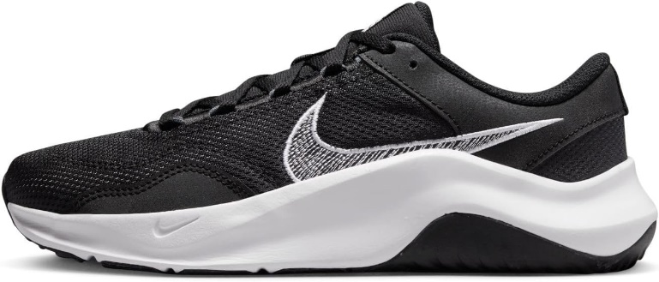

Product details
Top highlights
Origin
Imported
Sole material
Rubber
Shaft height
Ankle Strap
Outer material
Mesh

About this item
- Plush collar helps you slip in and out of the shoe easier.
- Rubber wraps up from the sole to the sides for added durability.
- The outsole is made with at least 8% Nike Grind material, made from scraps from the footwear manufacturing process.?
- Grippy traction helps keep you moving on various gym surfaces.

Special Features | Cushioned
Closure Type | Lace-Up
Sport Type | Gym
Specific Uses For Product | Sports
Shoe Type | Athletic Shoe
Water Resistance Level | Not Water Resistant
Strap Type | Ankle Strap
Has Shoe Adjustability | No
Insole Cushioning | Foam
Cushioning Level | Moderate
Lace Ends | Plastic Aglets
Lace Closure | Eyelets

4.2 out of 5Average rating: 4.2 out of 5 stars
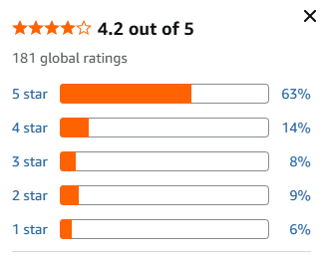

https://www.amazon.com/Nike-Womens-Legend-Essential-Trainers/dp/B0B5V7Y6RK/ref=sr_1_5?crid=27OEPO20LN4Y4&dib=eyJ2IjoiMSJ9.2PFhUA8B9pONana_R3h5RXRo8XYYcQgBWu1kx9KIKXdnUKA-mN9009d81JjdKQtCt1M5-fnqVYaXtICDXJvcPZkW8_aQUve9u44ZsNVMSUSjOC-9eEL5G60DELRCphZg7KEVT6Qyn85amZWzK0Of7_P5YDdqep-9SrEWOiFh6MyMLeDwS1E6BRtBqDopbDdPO3tZPObYRTWvI3-2a4Lm5OM1-ceIJpxrIqAjPV5Iri5ouMutqSXYm2P9v0D1aTVNUbu4truXqt-eJJ9Ky2ThS9EDA-tRxou3oPWoE8Rf3k0.5ALMZw1qm2_7wrIDFWkoVV_FlAoslpYtZUzFieYWqpw&dib_tag=se&keywords=nike%2Buno%2Bwomen&qid=1780385645&sprefix=nike%2Buno%2Bwomen%2Caps%2C453&sr=8-5&th=1&psc=1

03.Project Cloud Platform Sneakers for Women.

LKR16,541.85
LKR 35,941.23 Shipping & Import Charges to Sri Lanka Details

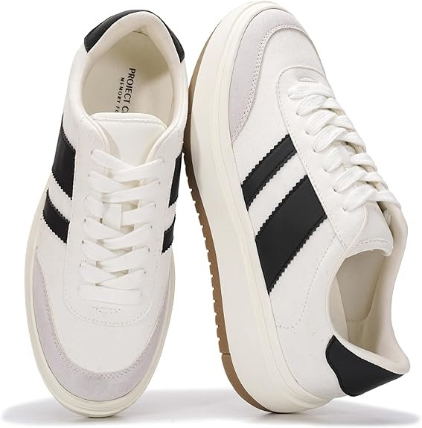

Product details
Top highlights
Sole material
Rubber
Outer material
Leather
Inner material
Memory Foam
Closure type
Lace-Up

About this item
- 𝗦𝘁𝘆𝗹𝗶𝘀𝗵 𝗗𝗲𝘀𝗶𝗴𝗻: The Project Cloud shoes for women sneakers feature a versatile design available in various colors. These white sneakers for women, with bold stripes, are a stylish staple for any wardrobe. Perfect for any woman looking to add a touch of sophistication to their outfit.
- 𝗣𝗹𝗮𝘁𝗳𝗼𝗿𝗺 𝗦𝗼𝗹𝗲: These women sneakers come with an elevated platform sole, adding a trendy edge and extra height. These platform shoes for women are perfect for making a statement, combining style and support effortlessly.
- 𝗖𝗼𝗺𝗳𝗼𝗿𝘁𝗮𝗯𝗹𝗲 𝗙𝗶𝘁: Designed with a cushioned insole and padded collar, these women's shoes offer all-day comfort. The breathable materials ensure your feet stay cozy, making these womens shoes fashion sneakers ideal for extended wear.
- 𝗕𝗮𝗰𝗸 𝘁𝗼 S𝗰𝗵𝗼𝗼𝗹 𝗘𝘀𝘀𝗲𝗻𝘁𝗶𝗮𝗹𝘀: These womens sneakers combine comfort, style, and durability, making them an ideal addition to your wardrobe and a perfect school shoes. Step into the new school year with confidence, knowing that your feet are supported and stylishly dressed.
- 𝗩𝗲𝗿𝘀𝗮𝘁𝗶𝗹𝗲 𝗦𝘁𝘆𝗹𝗲: Suitable for various occasions, these casual sneakers for women can be paired with jeans, dresses, or shorts. Available in multiple colors, including black sneakers for women, these women's fashion sneakers offer endless styling possibilities for any outfit.

Special Features | Slip Resistant
Closure Type | Lace-Up
Sport Type | Running
Specific Uses For Product | Casual
Shoe Type | Athletic Shoe
Water Resistance Level | Water Resistant
Strap Type | Lace
Has Shoe Adjustability | Yes
Insole Cushioning | Foam or similar cushioning material
Arch Type | stability
Cushioning Level | Moderate
Lace Closure | Lace-Up
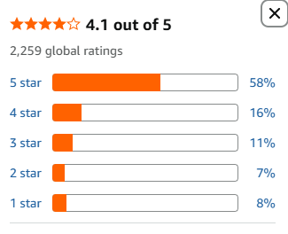

https://www.amazon.com/Project-Cloud-Sneakers-Women-Lightweight/dp/B0D5RMJTM6/ref=sr_1_12?crid=27OEPO20LN4Y4&dib=eyJ2IjoiMSJ9.2PFhUA8B9pONana_R3h5RXRo8XYYcQgBWu1kx9KIKXdnUKA-mN9009d81JjdKQtCt1M5-fnqVYaXtICDXJvcPZkW8_aQUve9u44ZsNVMSUSjOC-9eEL5G60DELRCphZg7KEVT6Qyn85amZWzK0Of7_P5YDdqep-9SrEWOiFh6MyMLeDwS1E6BRtBqDopbDdPO3tZPObYRTWvI3-2a4Lm5OM1-ceIJpxrIqAjPV5Iri5ouMutqSXYm2P9v0D1aTVNUbu4truXqt-eJJ9Ky2ThS9EDA-tRxou3oPWoE8Rf3k0.5ALMZw1qm2_7wrIDFWkoVV_FlAoslpYtZUzFieYWqpw&dib_tag=se&keywords=nike%2Buno%2Bwomen&qid=1780385645&sprefix=nike%2Buno%2Bwomen%2Caps%2C453&sr=8-12&th=1&psc=1

04.Under Armour Women's Charged Assert.

-28% LKR18,013.
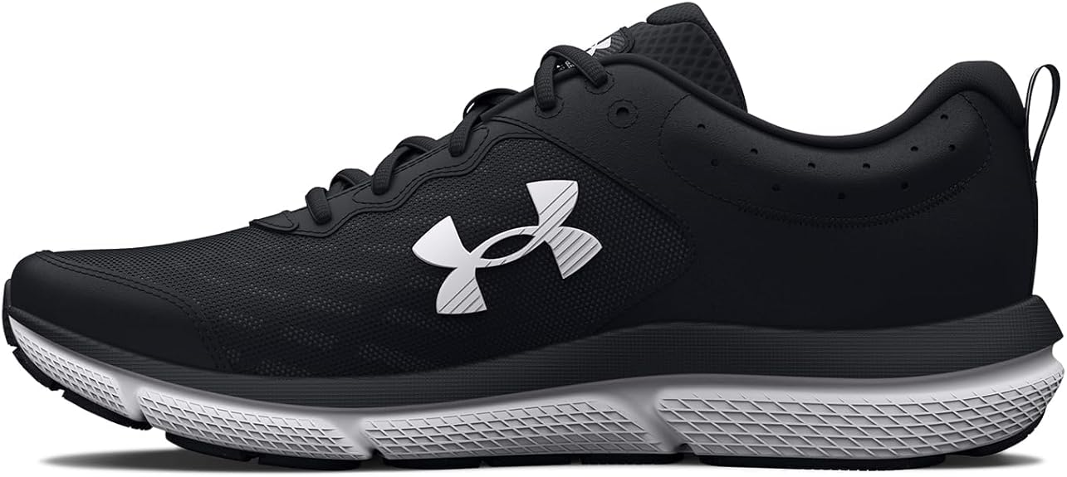

Top highlights
Origin
Made in the USA or Imported
Sole material
Rubber
Outer material
Mesh
Inner material
Ethylene Vinyl Acetate

About this item
- Lightweight, breathable mesh upper with synthetic overlays for added durability & support
- EVA sockliner provides soft, step-in comfort
- Charged Cushioning midsole uses compression molded foam for ultimate responsiveness & durability
- Solid rubber outsole covers high impact zones for greater durability with less weight
- Offset: 10mm
- Weight: 8.9 oz.

Special Features | Flexible
Closure Type | Lace-Up
Sport Type | Running
Specific Uses For Product | Sports
Shoe Type | Athletic Shoe
Water Resistance Level | Not Water Resistant
Strap Type | Fabric
Has Shoe Adjustability | Yes
Insole Cushioning | Ethylene Vinyl Acetate
Arch Type | cushioning
Cushioning Level | Moderate

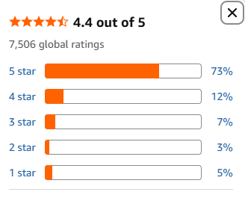

https://www.amazon.com/Under-Armour-Womens-Charged-Running/dp/B09XBTF1FC/ref=sr_1_17?crid=27OEPO20LN4Y4&dib=eyJ2IjoiMSJ9.2PFhUA8B9pONana_R3h5RXRo8XYYcQgBWu1kx9KIKXdnUKA-mN9009d81JjdKQtCt1M5-fnqVYaXtICDXJvcPZkW8_aQUve9u44ZsNVMSUSjOC-9eEL5G60DELRCphZg7KEVT6Qyn85amZWzK0Of7_P5YDdqep-9SrEWOiFh6MyMLeDwS1E6BRtBqDopbDdPO3tZPObYRTWvI3-2a4Lm5OM1-ceIJpxrIqAjPV5Iri5ouMutqSXYm2P9v0D1aTVNUbu4truXqt-eJJ9Ky2ThS9EDA-tRxou3oPWoE8Rf3k0.5ALMZw1qm2_7wrIDFWkoVV_FlAoslpYtZUzFieYWqpw&dib_tag=se&keywords=nike%2Buno%2Bwomen&qid=1780385645&sprefix=nike%2Buno%2Bwomen%2Caps%2C453&sr=8-17&th=1&psc=1

05.Guess Women's Loven Sneaker.

LKR21,547.50
LKR 36,223.00 Shipping & Import Charges to Sri Lanka

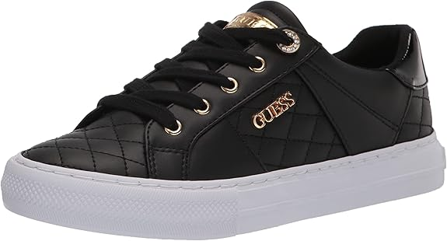

Top highlights

Fabric type
100% Synthetic
Origin
Imported
Sole material
Rubber
Outer material
Rubber

About this item
- Chic Quilted Design: Features a stylish quilted faux leather upper that adds a touch of sophistication and texture to your casual wardrobe, making these sneakers easy to dress up or down.
- Customizable Fit: Lace-up closure ensures a secure, adjustable fit that allows you to style the sneakers your way while providing reliable support throughout the day.
- Classic Silhouette: Designed with a timeless round toe that offers both style and ample room for natural toe movement, enhancing all-day comfort.
- Breathable Interior: Soft fabric lining helps keep your feet cool and comfortable, making these sneakers ideal for everyday wear and extended outings.
- All-Day Comfort: Cushioned footbed provides exceptional underfoot comfort and support, helping to reduce foot fatigue whether you’re on the go or on your feet for hours.
- Subtle Lift: 1" platform heel adds just the right amount of height for a flattering look without sacrificing stability or ease of movement.

Special Features | Rubber sole
Closure Type | Lace-Up
Sport Type | Walking
Specific Uses For Product | Sports, Maternity, Medical
Embellishment Feature | Logo
Shoe Type | Athletic Shoe
Water Resistance Level | Not Water Resistant
Strap Type | lace_up
Has Shoe Adjustability | Yes
Insole Cushioning | Ethylene Vinyl Acetate
Cushioning Level | moderate
Lace Ends | Plastic tips or aglets
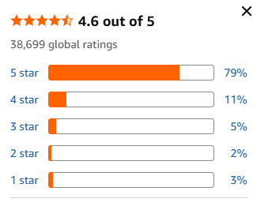

https://www.amazon.com/GUESS-Womens-Loven-Sneaker-Black/dp/B08DXN3XCH/ref=sr_1_18?crid=27OEPO20LN4Y4&dib=eyJ2IjoiMSJ9.2PFhUA8B9pONana_R3h5RXRo8XYYcQgBWu1kx9KIKXdnUKA-mN9009d81JjdKQtCt1M5-fnqVYaXtICDXJvcPZkW8_aQUve9u44ZsNVMSUSjOC-9eEL5G60DELRCphZg7KEVT6Qyn85amZWzK0Of7_P5YDdqep-9SrEWOiFh6MyMLeDwS1E6BRtBqDopbDdPO3tZPObYRTWvI3-2a4Lm5OM1-ceIJpxrIqAjPV5Iri5ouMutqSXYm2P9v0D1aTVNUbu4truXqt-eJJ9Ky2ThS9EDA-tRxou3oPWoE8Rf3k0.5ALMZw1qm2_7wrIDFWkoVV_FlAoslpYtZUzFieYWqpw&dib_tag=se&keywords=nike%2Buno%2Bwomen&qid=1780385645&sprefix=nike%2Buno%2Bwomen%2Caps%2C453&sr=8-18&th=1&psc=1

06.LANSNBO Waterproof Steel Toe Shoes for Women.

LKR18,560.68
LKR 35,404.20 Shipping & Import Charges to Sri Lanka .

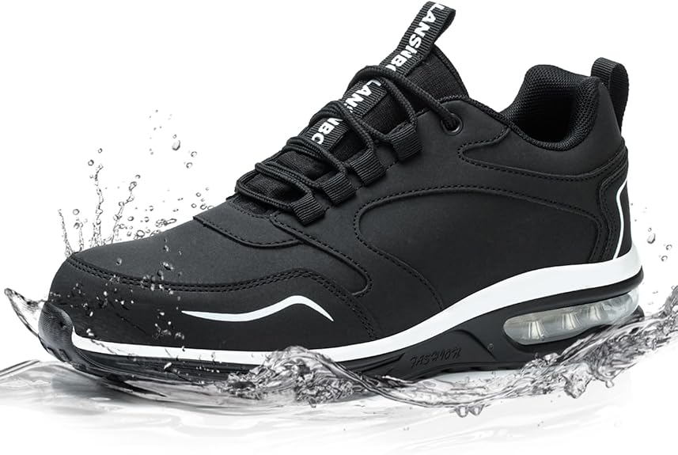

Product details

Top highlights
Fabric type
Lightweight Mesh Skin-friendly
Origin
Imported
Sole material
Rubber
Outer material
Polyurethane (PU)

About this item
- Waterproof: LANSNBO work shoes provide dependable waterproofing, keeping feet dry in damp conditions. Whether it's raining, encountering puddles, or hiking, they effectively repel moisture, offering comfort and protection in various environments.
- slip-resistant design:Our safety shoes feature a rubber outsole with tire-like tread patterns, providing reliable traction on oily kitchen floors, slick restaurant surfaces, or damp construction sites. They deliver stability and safety in various conditions.
- Steel Toe Caps: LANSNBO safety shoes include steel toe caps that meet ASTM F2413-18 standards, providing protection against impact and compression in various work environments to keep your feet safe.
- Memory Foam Insoles & Puncture-Resistant Midsoles: Our shoes are equipped with memory foam insoles for all-day comfort and Kevlar midsoles that meet safety standards for puncture resistance, providing protection from sharp objects.
- Fashion meets utility: Our safety shoes combine style with practicality, making them suitable for both work and everyday wear. With a design that is both fashionable and functional, you can stay safe on the job while expressing your style.

Special Features | Cushioned, Lightweight, Puncture Resistant, Slip Resistant, steel-toed
Closure Type | Lace-Up
Sport Type | Hiking
Shoe Type | Athletic Shoe
Water Resistance Level | Waterproof
Strap Type | Lace-Up
Has Shoe Adjustability | No
Insole Cushioning | Polyurethane Foam (Memory Foam)
Arch Type | Medium Arch
Cushioning Level | maximum

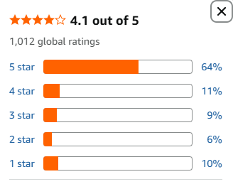

https://www.amazon.com/LANSNBO-Puncture-Proof-Comfortable-Lightweight-Construction/dp/B0CSWQNR1T/ref=sr_1_29_sspa?crid=27OEPO20LN4Y4&dib=eyJ2IjoiMSJ9.2PFhUA8B9pONana_R3h5RXRo8XYYcQgBWu1kx9KIKXdnUKA-mN9009d81JjdKQtCt1M5-fnqVYaXtICDXJvcPZkW8_aQUve9u44ZsNVMSUSjOC-9eEL5G60DELRCphZg7KEVT6Qyn85amZWzK0Of7_P5YDdqep-9SrEWOiFh6MyMLeDwS1E6BRtBqDopbDdPO3tZPObYRTWvI3-2a4Lm5OM1-ceIJpxrIqAjPV5Iri5ouMutqSXYm2P9v0D1aTVNUbu4truXqt-eJJ9Ky2ThS9EDA-tRxou3oPWoE8Rf3k0.5ALMZw1qm2_7wrIDFWkoVV_FlAoslpYtZUzFieYWqpw&dib_tag=se&keywords=nike%2Buno%2Bwomen&qid=1780385645&sprefix=nike%2Buno%2Bwomen%2Caps%2C453&sr=8-29-spons&sp_csd=d2lkZ2V0TmFtZT1zcF9tdGY&th=1&psc=1

07. Treesky Non Slip Work Shoes.

LKR16,240.18
LKR 35,294.80 Shipping & Import Charges to Sri Lanka .

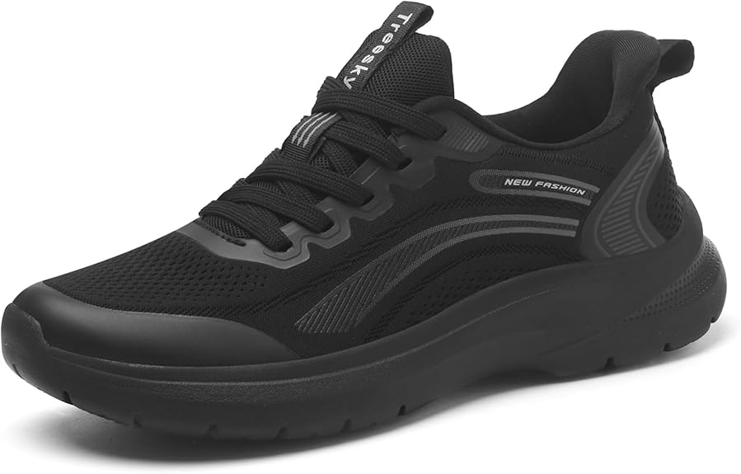

Product details.

Top highlights
Origin
Imported
Sole material
Rubber
Outer material
Polyester
Inner material
Mesh

About this item
- PRO-GRADE SLIP RESISTANCE: Engineered with a premium non-slip rubber outsole, delivering superior grip on wet, greasy, or slippery floors. Move with total confidence and stay safe in fast-paced kitchens, restaurants, or nursing environments. (Note: The numbers on the insole are factory mold codes, not the shoe size. Please refer to the tongue label for accurate sizing.)
- ULTRA-LIGHTWEIGHT CUSHIONING: Noticeably lighter than traditional bulky work shoes. It features a high-performance, injection-molded EVA foam midsole to effectively absorb impact. This professional lightweight construction is specifically engineered to reduce foot and leg fatigue during long shifts and extended standing.
- SOFT & BREATHABLE UPPER: The upper is crafted with a blend of premium ocean yarn and spandex. Made via seamless thermo-welding, this elastic combination provides a soft, breathable fit that keeps feet cool and dry.
- ENHANCED WEAR RESISTANCE: The inner heel is dual-reinforced with high-density, tear-resistant mesh and a premium anti-abrasion lining. This structural design effectively withstands the wear and tear of long-term walking. Built for demanding work environments, it significantly extends the shoe's lifespan.
- SECURE & STABLE FIT: Features a reliable lace-up system to provide essential ankle stability and a customized fit. This supportive structure keeps your feet securely in place, making it the perfect daily work companion for nurses, chefs, waitresses, and retail professionals.

Special Features | All Weather Grip, Breathable, Cushioned, Lightweight, Slip Resistant
Closure Type | Lace-Up
Specific Uses For Product | Medical
Shoe Type | Athletic Shoe
Water Resistance Level | Not Water Resistant
Strap Type | lace_up
Has Shoe Adjustability | Yes
Insole Cushioning | foam
Cushioning Level | moderate
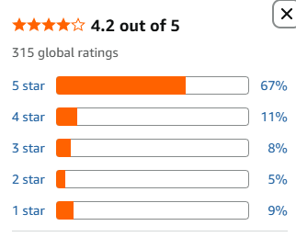

https://www.amazon.com/Treesky-Slip-Shoes-Women-Service/dp/B0F9DZK36F/ref=sr_1_42_sspa?crid=27OEPO20LN4Y4&dib=eyJ2IjoiMSJ9.2PFhUA8B9pONana_R3h5RXRo8XYYcQgBWu1kx9KIKXdnUKA-mN9009d81JjdKQtCt1M5-fnqVYaXtICDXJvcPZkW8_aQUve9u44ZsNVMSUSjOC-9eEL5G60DELRCphZg7KEVT6Qyn85amZWzK0Of7_P5YDdqep-9SrEWOiFh6MyMLeDwS1E6BRtBqDopbDdPO3tZPObYRTWvI3-2a4Lm5OM1-ceIJpxrIqAjPV5Iri5ouMutqSXYm2P9v0D1aTVNUbu4truXqt-eJJ9Ky2ThS9EDA-tRxou3oPWoE8Rf3k0.5ALMZw1qm2_7wrIDFWkoVV_FlAoslpYtZUzFieYWqpw&dib_tag=se&keywords=nike%2Buno%2Bwomen&qid=1780385645&sprefix=nike%2Buno%2Bwomen%2Caps%2C453&sr=8-42-spons&sp_csd=d2lkZ2V0TmFtZT1zcF9tdGY&th=1&psc=1

08.Padgene Womens Sneakers.

LKR7,289.68
LKR 27,660.36 Shipping & Import Charges to Sri Lanka Details

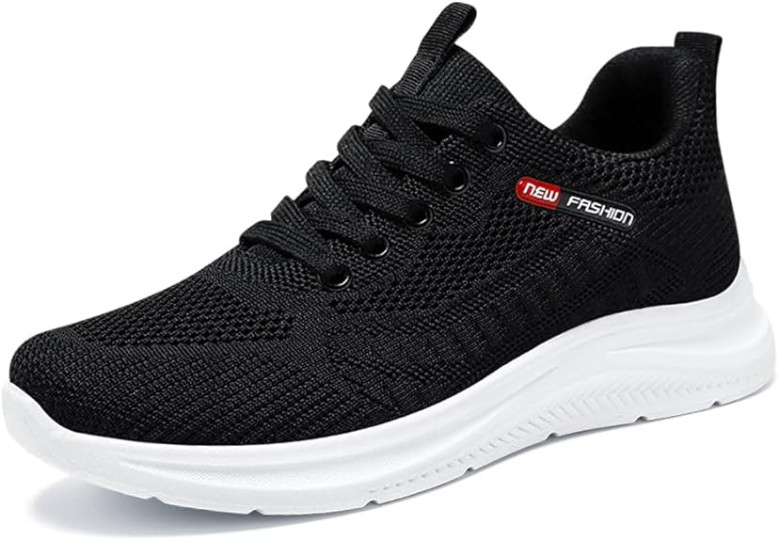

Product details

Top highlights
Sole material
Ethylene Vinyl Acetate
Outer material
Mesh
Inner material
Mesh
Closure type
Lace-Up

About this item
- ★【Breathable Tennis Upper】★ --- Crafted from lightweight and breathable materials, our tennis shoes feature a mesh upper that ensures complete breathability. Your feet will experience unparalleled comfort and flexibility, as these athletic shoes are thoughtfully designed with your utmost comfort in mind.
- ★【All-day Comfort】★ --- Experience continuous comfort with the memory foam insole that absorbs shock, while the cushioned outsole ensures proper foot positioning, enhancing overall comfort. With outstanding shock absorption and pain relief effects, it offers moderate control and support, delivering a relaxing, fatigue-free experience throughout the day.
- ★【Long - Lasting Performance】★ --- Designed to keep up with your active lifestyle, these women's tennis shoes are crafted from premium, durable materials that stand up to daily wear and tear. Every detail—from the reinforced upper to the sturdy sole—is built for long-lasting performance, so you can rely on them match after match, mile after mile.
- ★【Perfect For】★ --- This fashionable women's sports shoe is perfect for for running, walking, working, weight training, park activities, boating, cycling, jogging, gardening, lawn sports, equestrian pursuits, basketball, rowing, athletics, tennis, volleyball, football, driving, and yoga. These casual daily shoes are designed to add more enjoyment to your life.cushioned
- ★【Special Design】★ --- The lace-up design on these women's sneakers lets you customize the fit to match your foot shape and personal preference, delivering a snug, secure feel that keeps them in place during movement. Plus, the soft inner lining and cushioned collar provide extra comfort by reducing friction and pressure on your feet.

Features & Specs
Special Features | slipper-outdoor-sole
Closure Type | Lace-Up
Sport Type | Multi-Sport
Specific Uses For Product | Sports
Shoe Type | Athletic Shoe
Water Resistance Level | Not Water Resistant
Strap Type | lace_up
Has Shoe Adjustability | Yes
Insole Cushioning | Cushioned
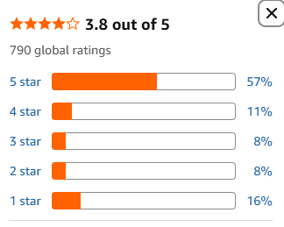

https://www.amazon.com/Padgene-Sneakers-Lightweight-Breathable-Comfortable/dp/B0G241S4VQ/ref=sr_1_26?crid=27OEPO20LN4Y4&dib=eyJ2IjoiMSJ9.2PFhUA8B9pONana_R3h5RXRo8XYYcQgBWu1kx9KIKXdnUKA-mN9009d81JjdKQtCt1M5-fnqVYaXtICDXJvcPZkW8_aQUve9u44ZsNVMSUSjOC-9eEL5G60DELRCphZg7KEVT6Qyn85amZWzK0Of7_P5YDdqep-9SrEWOiFh6MyMLeDwS1E6BRtBqDopbDdPO3tZPObYRTWvI3-2a4Lm5OM1-ceIJpxrIqAjPV5Iri5ouMutqSXYm2P9v0D1aTVNUbu4truXqt-eJJ9Ky2ThS9EDA-tRxou3oPWoE8Rf3k0.5ALMZw1qm2_7wrIDFWkoVV_FlAoslpYtZUzFieYWqpw&dib_tag=se&keywords=nike%2Buno%2Bwomen&qid=1780385645&sprefix=nike%2Buno%2Bwomen%2Caps%2C453&sr=8-26&th=1&psc=1

09.SKDOIUL Women Running Shoes.

LKR12,232.35
LKR 33,385.36 Shipping & Import Charges to Sri Lanka Details
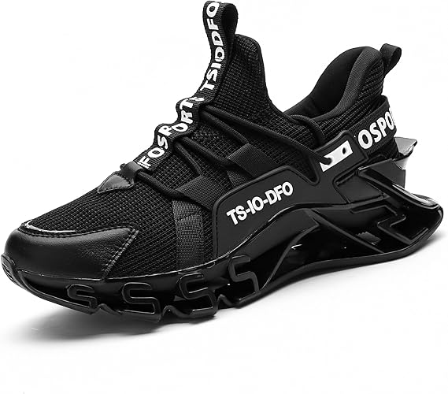

Product details

Top highlights
Sole material
Thermoplastic Elastomers
Outer material
Mesh
Inner material
Mesh
Closure type
Lace-Up

About this item
- Comfortable and breathable fabric.
- Non-slip Wear-resistant outsole.
- slip on design easy to wear, fashion colour with everything.
- Multi-color choose: Red pink black light grey yellow orange rose red Fluorescent green.
- Occasion: casual, walking, running,driving , training, indoor, sports, outdoor, travel, workout and so on.

Special Features | Slip Resistant
Closure Type | Lace-Up
Sport Type | Running
Specific Uses For Product | Sports
Shoe Type | Athletic Shoe
Water Resistance Level | Not Water Resistant
Strap Type | lace_up
Insole Cushioning | EVA Foam
Arch Type | Medium Arch
Cushioning Level | Moderate
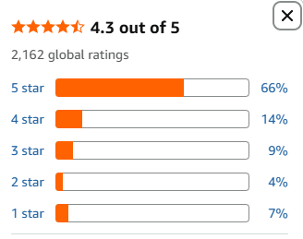

https://www.amazon.com/SKDOIUL-Running-Sneakers-Athletic-Walking/dp/B0GC5B573K/ref=sr_1_33?crid=27OEPO20LN4Y4&dib=eyJ2IjoiMSJ9.2PFhUA8B9pONana_R3h5RXRo8XYYcQgBWu1kx9KIKXdnUKA-mN9009d81JjdKQtCt1M5-fnqVYaXtICDXJvcPZkW8_aQUve9u44ZsNVMSUSjOC-9eEL5G60DELRCphZg7KEVT6Qyn85amZWzK0Of7_P5YDdqep-9SrEWOiFh6MyMLeDwS1E6BRtBqDopbDdPO3tZPObYRTWvI3-2a4Lm5OM1-ceIJpxrIqAjPV5Iri5ouMutqSXYm2P9v0D1aTVNUbu4truXqt-eJJ9Ky2ThS9EDA-tRxou3oPWoE8Rf3k0.5ALMZw1qm2_7wrIDFWkoVV_FlAoslpYtZUzFieYWqpw&dib_tag=se&keywords=nike%2Buno%2Bwomen&qid=1780385645&sprefix=nike%2Buno%2Bwomen%2Caps%2C453&sr=8-33&th=1&psc=1

10. AVW Womens Non Slip Work Shoes.

LKR16,903.18
LKR 36,077.14 Shipping & Import Charges to Sri Lanka.

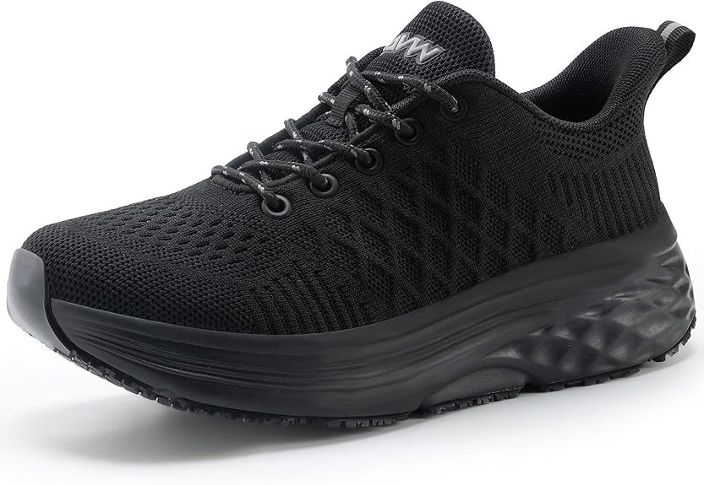

Product details

Top highlights
Sole material
Rubber
Outer material
Cotton
Inner material
Memory Foam
Closure type
Lace-Up

About this item
- CUSHIONED SOLE: Women's non-slip work shoes use EVA midsole with non-slip rubber patches to provide cushioning and soft support to relieve fatigue from long hours of standing.
- NON-SLIP SOLE：The soles have excellent anti-slip and anti-oil features with strong grip, allowing you to get the job done safely in slippery environments, such as restaurant kitchens.
- ARCH SUPPORT MEMORY FOAM INSOLE: Women's chef shoes feature a removable memory foam insole with arch support to relieve pressure from long hours of standing and enhance fit and comfort.
- BREATHABLE AND WATER RESISTANT UPPER: The upper of the women's food service shoes is made of high-quality knitted sock fabric, as well as special anti-liquid treatment, which is breathable and water resistant , so that your feet are comfortable all day long.
- SUITABLE FOR MULTIPLE OCCASIONS: These non-slip work shoes can do a lot of work, suitable for kitchens, restaurants, nursing homes, laboratories, factories, gas stations, warehouses and other work environments that require long periods of standing, and the fashionable design is also perfect for outdoor sports as well as daily traveling activities.

Features & Specs
Special Features | Slip Resistant
Closure Type | Lace-Up
Sport Type | Multi-purpose
Specific Uses For Product | Running
Shoe Type | Athletic Shoe
Water Resistance Level | Water Resistant
Strap Type | Lace-Up
Has Shoe Adjustability | No
Insole Cushioning | Foam
Cushioning Level | moderate
Lace Closure | Lace-Up

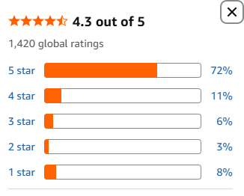

https://www.amazon.com/AVW-Resistant-Walking-Sneakers-Antideslizantes/dp/B0DL2ZX5YH/ref=sxin_17_pa_sp_search_thematic-asin_sspa?content-id=amzn1.sym.44342f3a-a64c-4ea5-abec-0bebc4593173%3Aamzn1.sym.44342f3a-a64c-4ea5-abec-0bebc4593173&crid=2E3RP45EJQDM3&cv_ct_cx=uno%2Bwomen&keywords=uno%2Bwomen&pd_rd_i=B0DL2ZX5YH&pd_rd_r=004a9199-fdce-41b9-9c23-35e73bc5c9b6&pd_rd_w=wn9cQ&pd_rd_wg=tE71n&pf_rd_p=44342f3a-a64c-4ea5-abec-0bebc4593173&pf_rd_r=PNZKR8AH1YCSJ8VXQ7H0&qid=1780387882&sbo=RZvfv%2F%2FHxDF%2BO5021pAnSA%3D%3D&sprefix=uno%2Bwomen%2Caps%2C364&sr=1-4-baa1f287-65d3-41a3-a655-8bbba0531537-spons&aref=BgPspizx7W&sp_csd=d2lkZ2V0TmFtZT1zcF9zZWFyY2hfdGhlbWF0aWM&th=1&psc=1

